**Project description and scope:**

**Description:**

A gym's or fitness center's operations and services are intended to be improved and streamlined through the Gym Management System initiative. This program is intended to make it easier to handle daily gym operations, member information, invoicing, scheduling, preferred location, administration, and workouts that one can perform at the gym to stay fit. For all people, exercising and staying fit are becoming increasingly vital and virtually a daily ritual. There are so many exercises to do, beginners or even professionals can wonder which exercise will target a specific muscle the best, and that is where this analysis can be useful. It allows for enhanced management of member registration, attendance, and invoicing processes, an enhanced member experience through faster scheduling, class registration as per the specific location, and individualized services, and an increase in revenue through precise billing, increased member retention, and optimum resource allocation. Comprehensive data analysis and reporting for business expansion and strategic decision-making lead to the automation of repetitive administrative activities, enabling the staff and trainers to concentrate more on member engagement and satisfaction.

**Scope:**

The Centralized Gym Management System project is to completely transform the way gyms operate by giving customers a smooth and simple experience while equipping gym owners and staff with powerful management capabilities. It contributes significantly to the expansion and success of the gym business. It addresses the following aspects, all with the goal of establishing a smooth and effective gym operation:

* Member administration
* Name
* Gender
* Age
* Contact
* Address
* Type of Fitness
* Session / Slots
* Branch
* Fitness Goals
* BMI

**Business rules:**

1. Customers must provide their name, phone number, and email ID during the registration process.
2. The join date cannot be greater than the end date.
3. Join Date cannot be NULL. If the End Date is NULL, the member is a life-time member.
4. A Customer can attend one session at a time.
5. Gym members should be at least 18 years old.
6. Membership fees must be paid on time to maintain an active membership status.
7. A customer weight report must be taken every first day of the month.
8. If Payment Type = Cash then 1.5% discount on Amount.

**Repository Data:**

Entities:

CUSTOMER

MEMBERSHIP

PAYMENT

CUSTOMER REPORTS

SCHEDULE

TRAINER

DATES

**Data Name and Definition:**

1. Customer: It includes the customer's information, like name, height, weight, and address
2. Payment: It depicts the customer's transactional activities
3. Membership: Tracks the registered customer's membership in the gym
4. Trainer: Details of the Trainer
5. Customer Reports: Refers to the individuals weight and BMI.
6. Schedule: Describes the length of time and time of the workout.
7. Dates: Gives the date-related information

**Entity Relationship Diagram:**

Below are the primary keys and foreign keys for all relations.

|  |  |  |
| --- | --- | --- |
| **Tables** | **Primary Keys** | **Foreign Keys** |
| CUSTOMER | CustomerID | DateID |
| MEMBERSHIP | MembershipID | CustomerID,  PaymentID,  DateID |
| PAYMENT | PaymentID | CustomerID,  DateID |
| CUSTOMER REPORTS | CustomerReportID | CustomerID,  DateID |
| SCHEDULE | ScheduleID | TrainerID,  MembershipID,  DateID |
| TRAINER | TrainerID | ScheduleID |
| DATES | DateID |  |

**Physical Diagram:**

**DDL:**

The DBMS that is chosen for this project is **Postgresql** and all the configurations have been done in pgadmin.

1. Table: **Customer**

*Creating enumerated datatypes in Gender and ActiveFlg columns to populate static values.*

CREATE TYPE GenderType AS ENUM ('M', 'F', 'Prefer not to respond');

CREATE TYPE Flg AS ENUM ('Y', 'N');

CREATE TABLE Customer (

CustomerID int PRIMARY KEY NOT NULL,

DateID int REFERENCES Dates(DateID) NOT NULL,

FirstName Varchar(20) NOT NULL,

LastName Varchar(20) NOT NULL,

Age int NOT NULL,

Gender GenderType,

Heightincm float,

Weightinlbs float,

Contact varchar(25),

Email varchar(25),

Address varchar(100),

JoinDate date,

ActiveFlg Flg NOT NULL

);

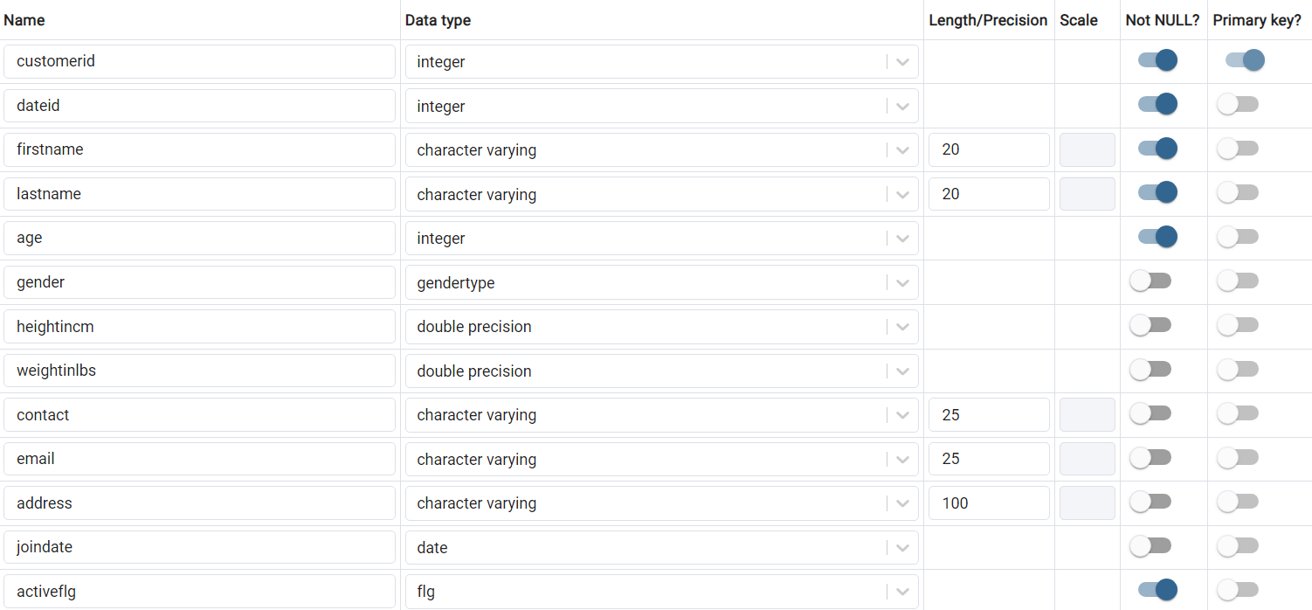

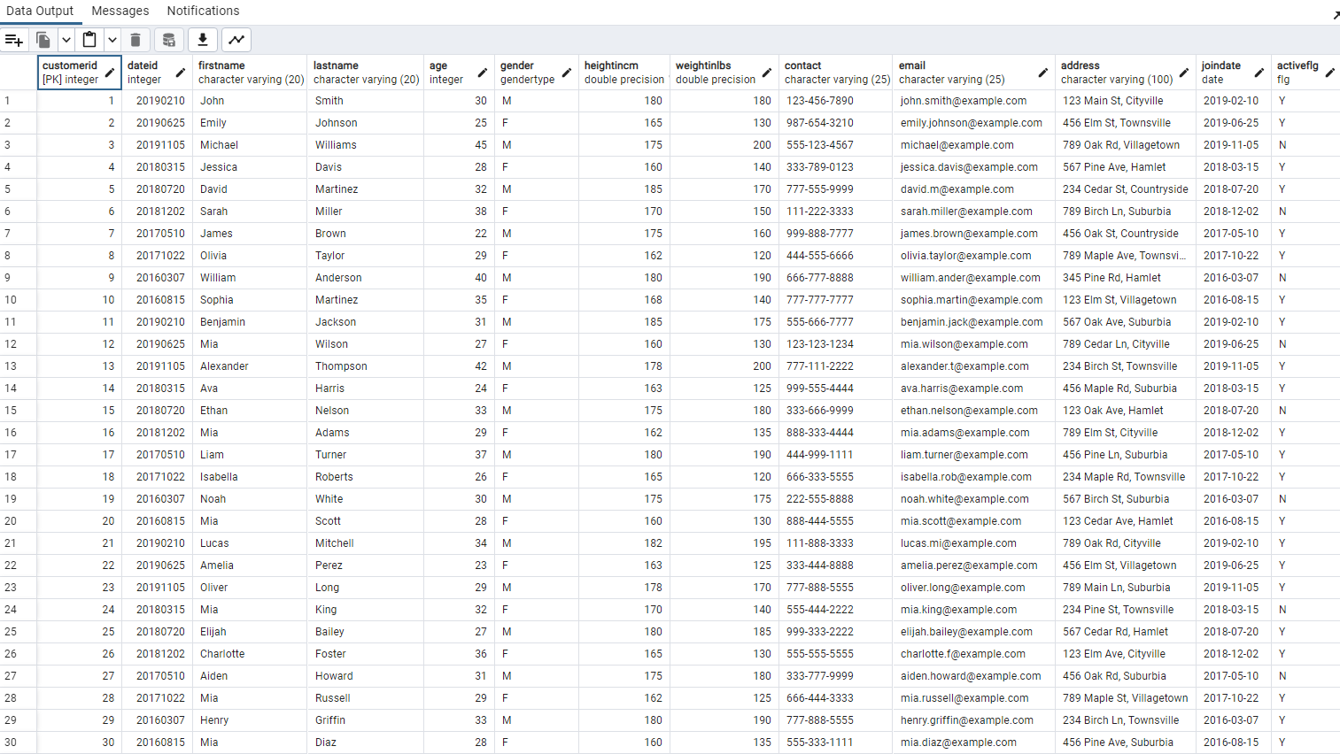

1. Table: **Membership**

CREATE TABLE Membership (

MembershipID int PRIMARY KEY NOT NULL,

CustomerID int REFERENCES Customer(CustomerID) NOT NULL,

PaymentID int REFERENCES Payment(PaymentID) NOT NULL,

DateID int REFERENCES Dates(DateID) NOT NULL,

Status varchar(10),

MembershipType varchar(30),

StartDate date,

EndDate date

);

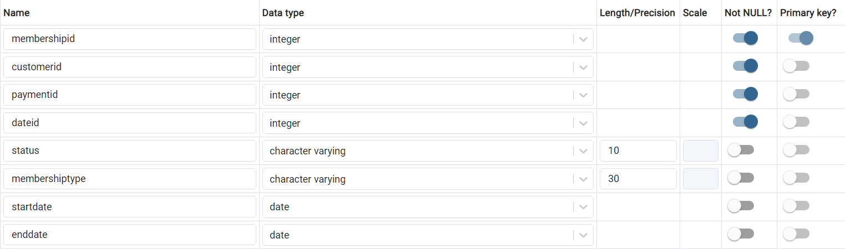

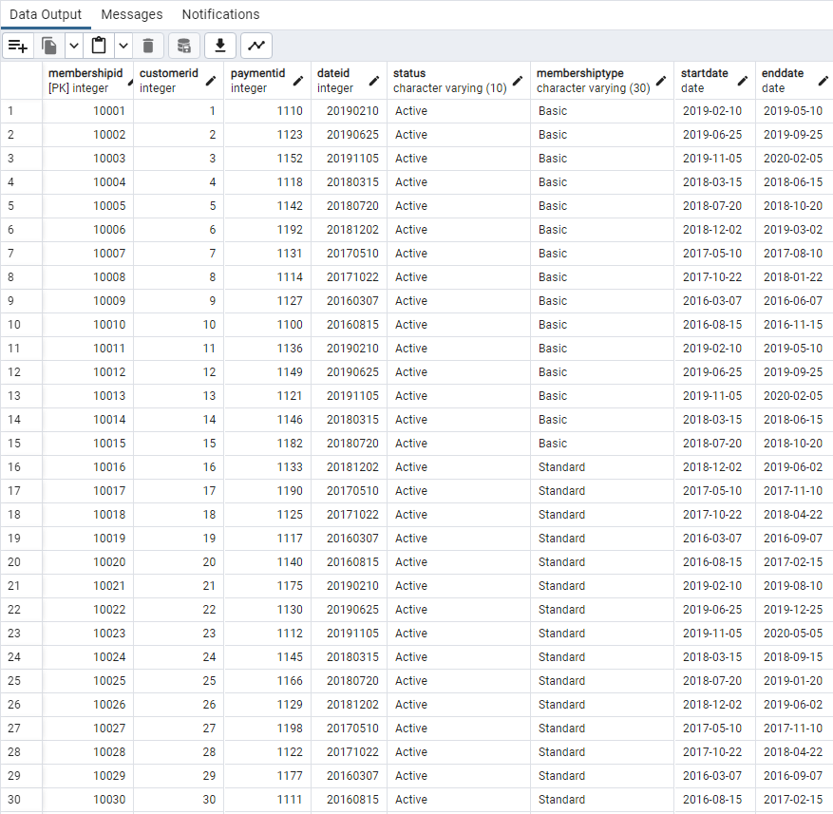

1. Table: **Customer Reports**

CREATE TABLE CustomerReports (

CustomerReportID int PRIMARY KEY NOT NULL,

CustomerID int REFERENCES Customer(CustomerID) NOT NULL,

DateID int REFERENCES Dates(DateID) NOT NULL,

CustomerReportDate date,

Weightinlbs float,

BMI float,

Notes varchar(80)

);

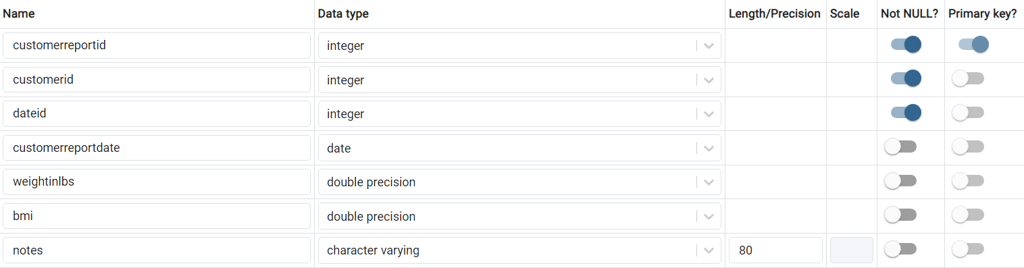

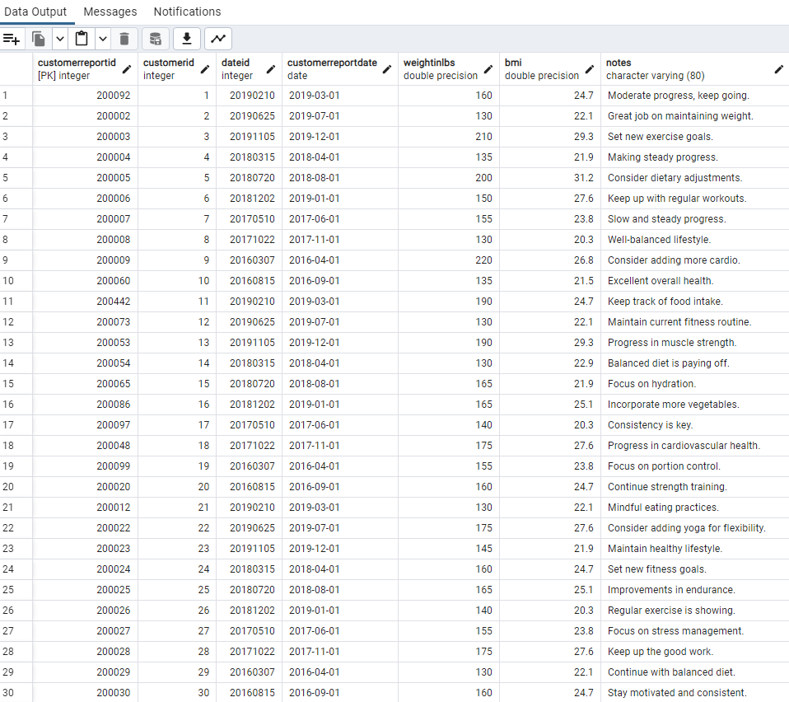

1. Table: **Payment**

CREATE TABLE Payment (

PaymentID int PRIMARY KEY NOT NULL,

CustomerID int REFERENCES Customer(CustomerID) NOT NULL,

DateID int REFERENCES Dates(DateID) NOT NULL,

PaymentDate date,

Amount float,

PaymentType varchar(20)

);

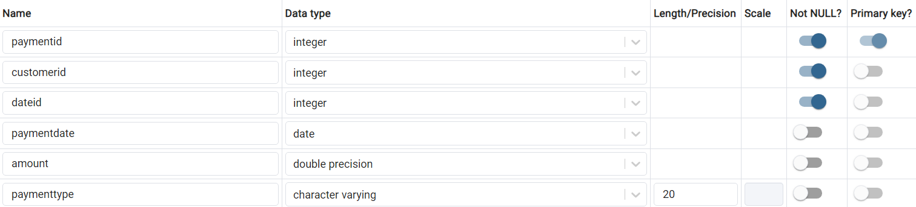

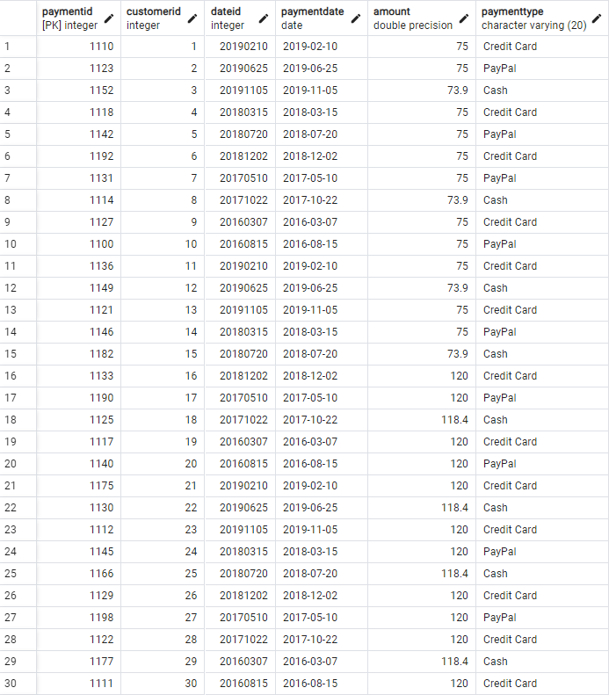

1. Table: **Dates**

CREATE TABLE Dates (

DateID int PRIMARY KEY NOT NULL,

FullDate date NOT NULL,

Week int,

MonthName varchar(10),

Quarter int,

DateYear int

);

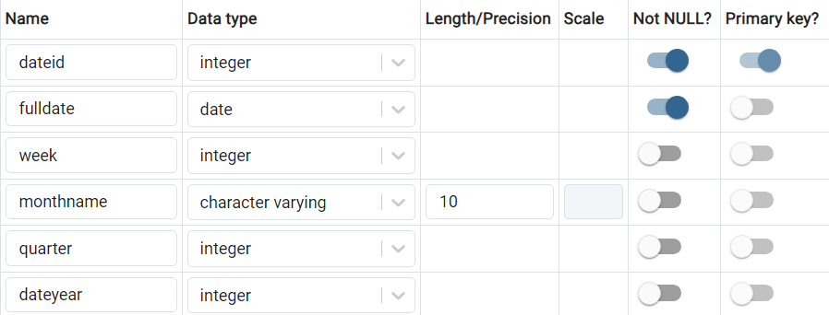

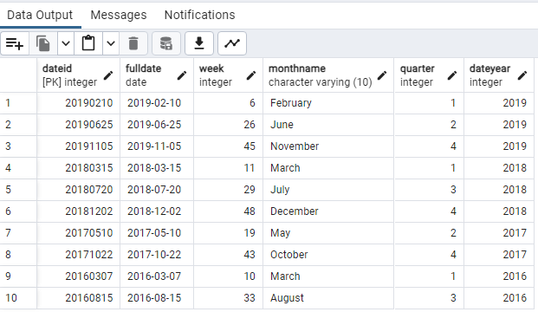

1. Table: **Schedule**

CREATE TABLE Schedule (

ScheduleID int PRIMARY KEY NOT NULL,

TrainerID int REFERENCES Trainer(TrainerID) NOT NULL,

MembershipID int REFERENCES Membership(MembershipID) NOT NULL,

DateID int REFERENCES Dates(DateID) NOT NULL,

ScheduleDate date,

StartTime timestamp,

EndTime timestamp,

Durationinminutes int,

DayOfWeek varchar(10)

);

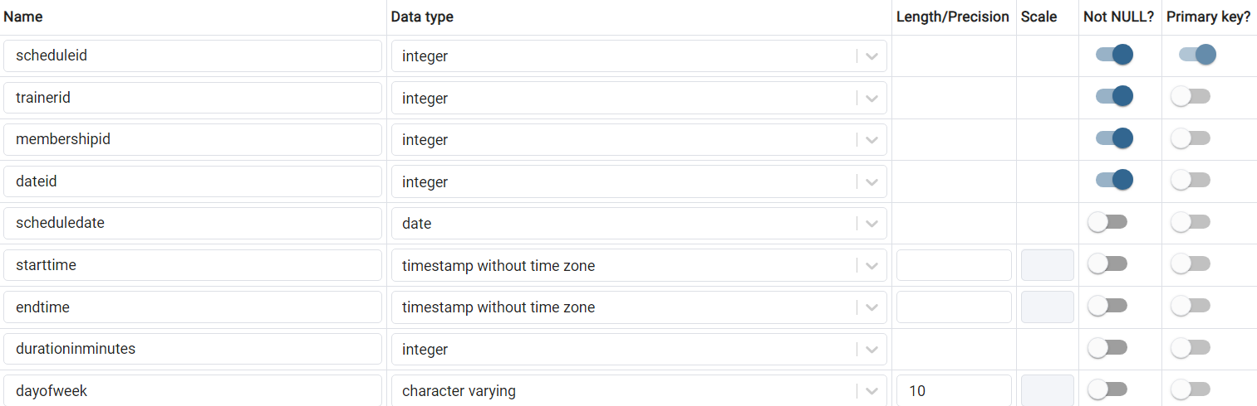

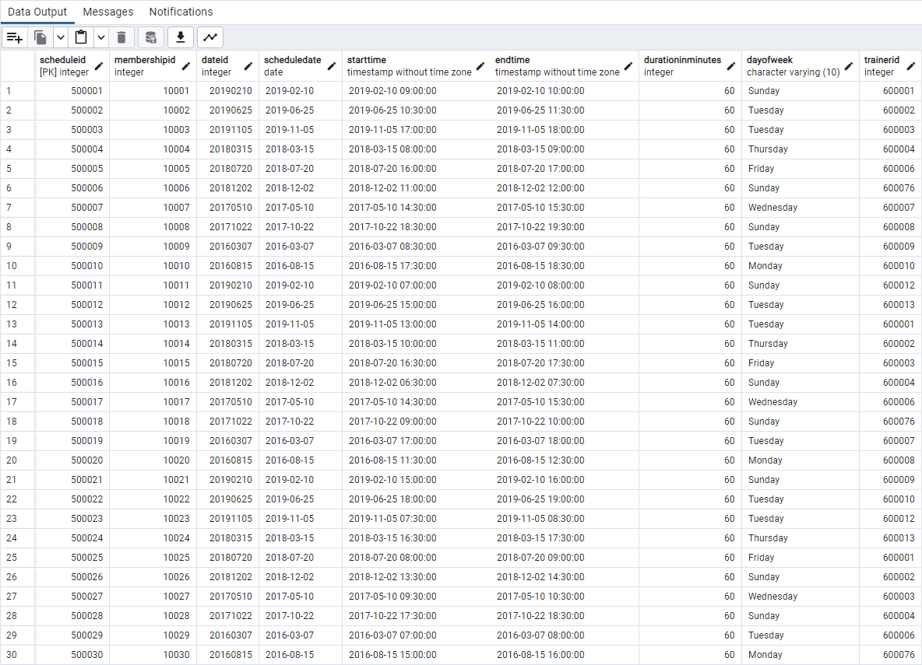

1. Table: **Trainer**

CREATE TABLE Trainer (

TrainerID int PRIMARY KEY NOT NULL,

ScheduleID int REFERENCES Schedule(ScheduleID) NOT NULL,

TrainerName varchar(20),

WorkoutType varchar(20)

);

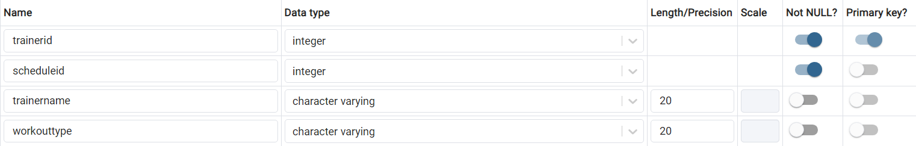

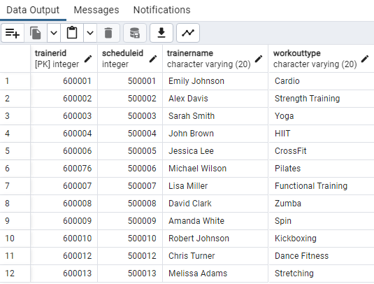

In order to create visually appealing and comprehensive dashboards, **Tableau Desktop** was used to create below dashboards as **Tableau** seamlessly integrates with Postgres database.

1. BMI (Body Mass Index) is a widely used metric to assess whether an individual's weight falls within a healthy range or if they are classified as normal, obese, or extremely obese. This dashboard aims to visually represent the distribution of individuals across these categories and offer valuable insights for gym management to create tailored workout programs or procure specific equipment for its members.

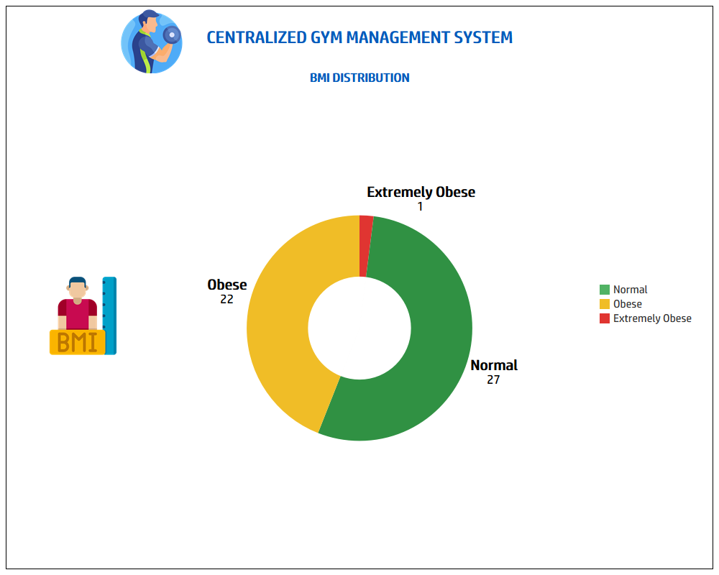

1. By focusing on average age, average BMI, and average revenue, this dashboard enables gym management and stakeholders to better understand their clientele, identify trends, and make informed decisions by gender.

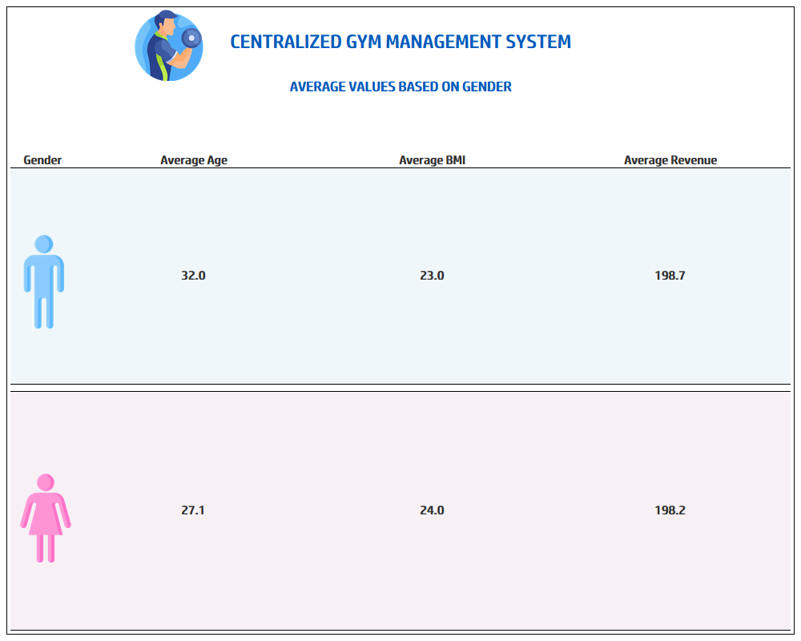

1. Following dashboard provides gym management and stakeholders with a clear overview of the financial performance, highlighting trends and fluctuations week by week providing comparison between current week and previous week along with tickers.

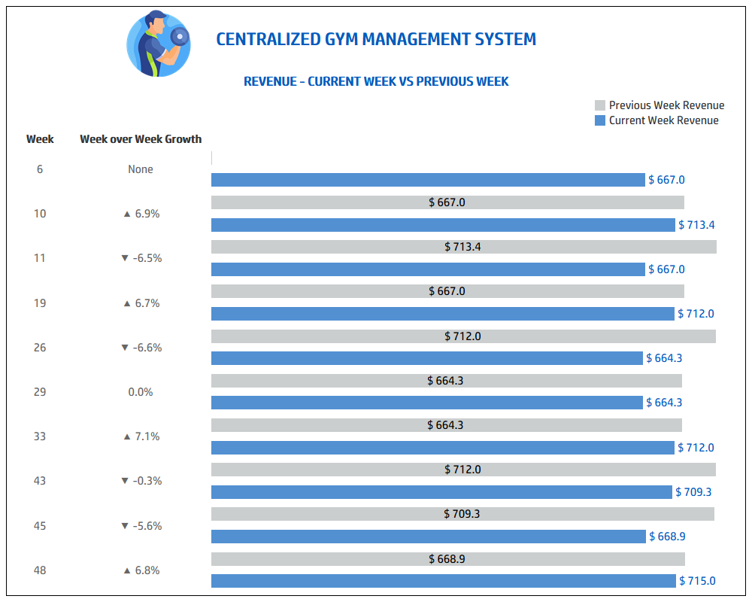

1. This Heat Map provides an immediate overview of high and low revenue days to optimize operations, marketing strategies, and staffing based on revenue fluctuations throughout the week.

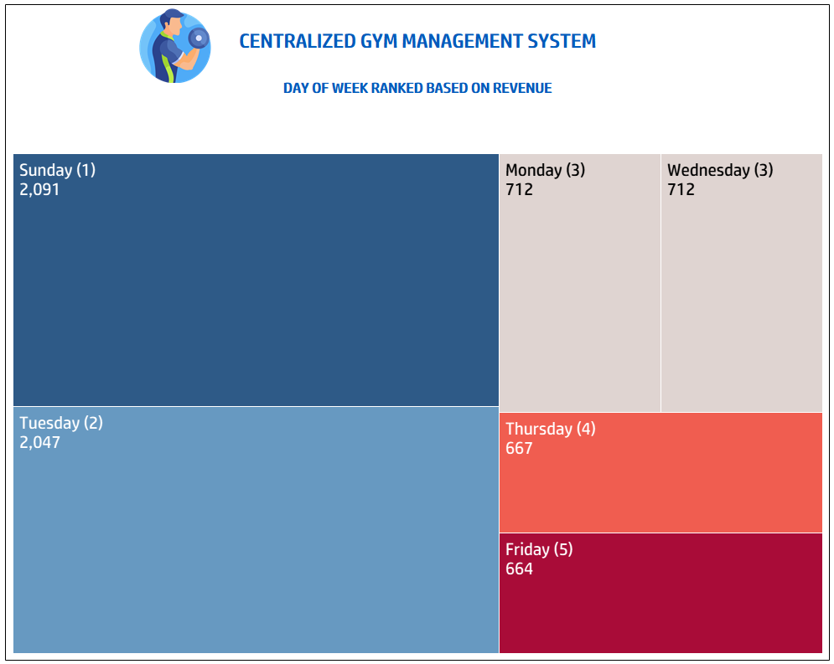

1. Availability of trainer is the most important aspect of any gym and ensuring minimal idle time for effective utilization of trainers. So the management should be able to track how many customers are assigned to each trainer, efficiently managing client assignments, monitor workload distribution, and optimize workouts.

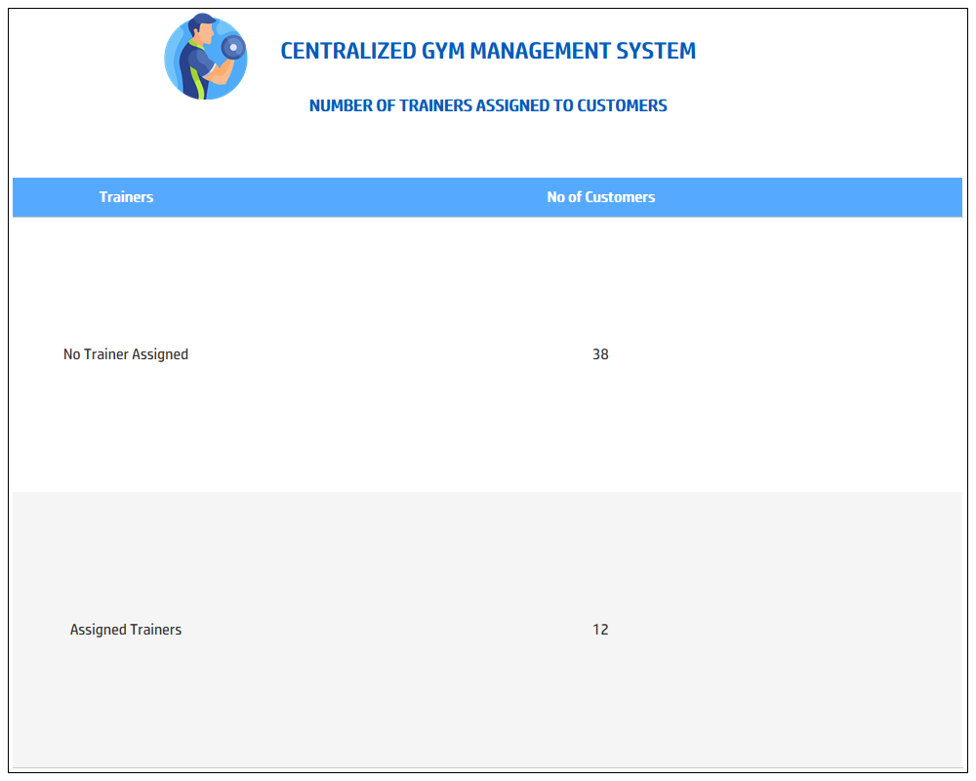

(Trainers grouped together to give overview of assigned and unassigned trainers, then expandable Group field created in Tableau to show workout type breakdown)

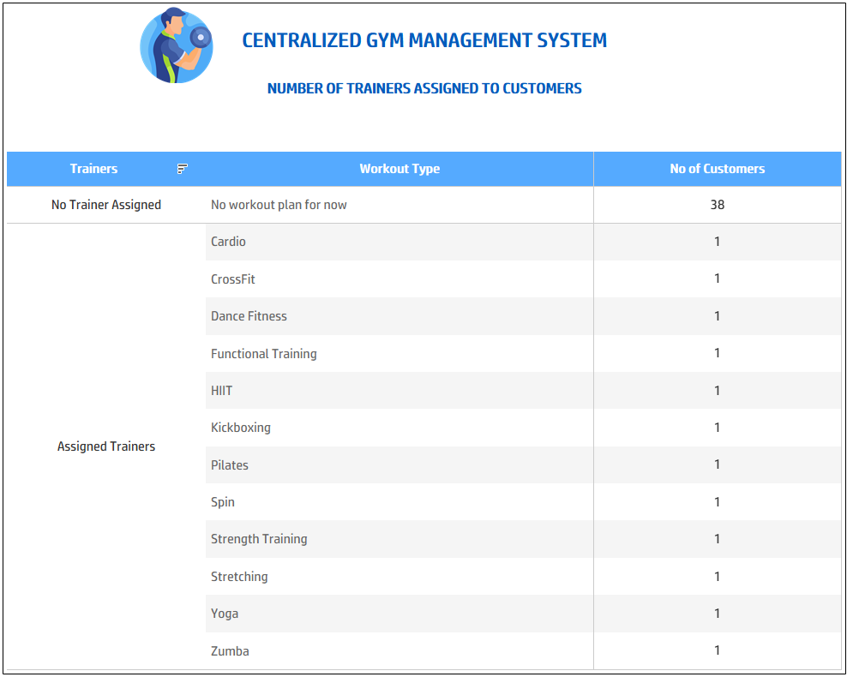

1. Along with identifying and acknowledging the achievements of customers who have made significant progress in their fitness journeys, it is important as well to focus on customers who are struggling with their fitness journey. Below dashboard aims to focus on this pain point by ranking customers by weight and extracting insights from their reports for trainer’s or instructor’s reference.

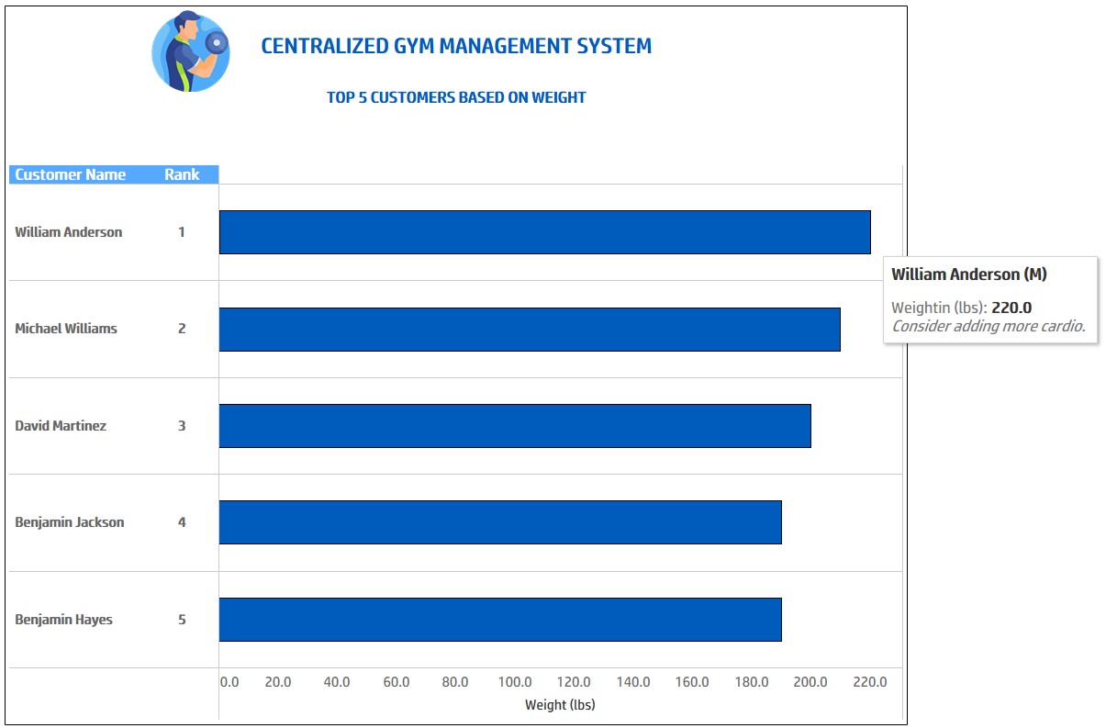

1. The bar chart illustrates the gym's total revenue for each year, offering a clear view of revenue growth or fluctuations over time. This chart provides a foundation for understanding the financial performance of the gym. It also assists the gym management in understanding payment trends, optimizing payment processing, and making informed financial decisions.

